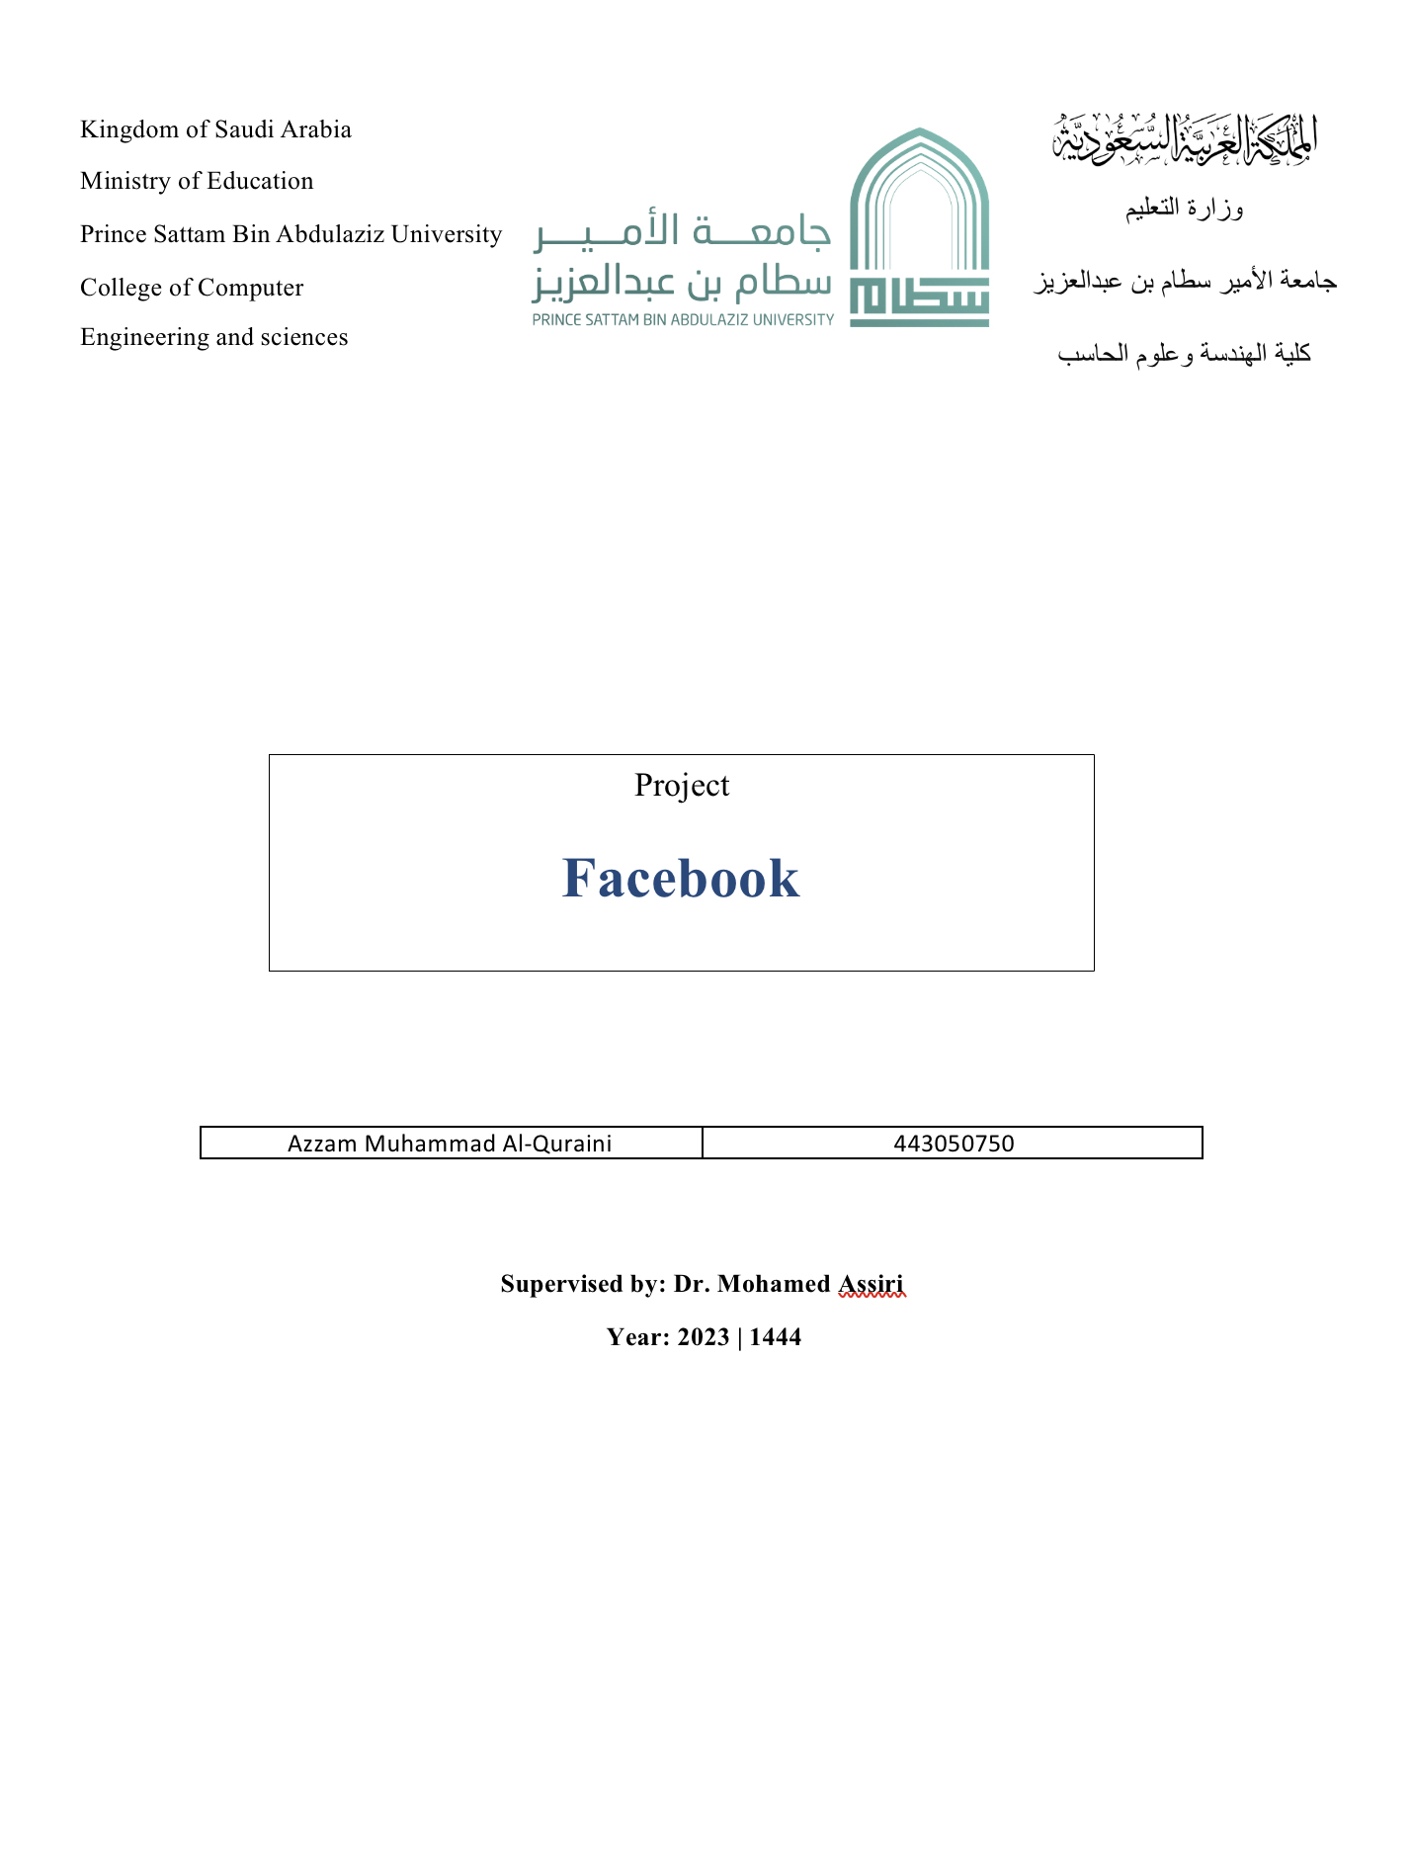

|1Page



1. **Group Project Proposal:**
   1. **Introduction**

**It is a website, considered the most famous social media, and can be defined as a large social network, and is managed by Meta as a joint stock company.**

As a free online social networking website, through which the user can communicate and interact with friends, family, colleagues, or any other user of the site, as this site allows users to create personal files through which photos and videos are uploaded and shared through the site, and send and receive messages, In addition to talking about what the user is doing, and many other services provided by this site.

* 1. **Statement of Problem**

The problem that Facebook solves is the difficulty of keeping in touch with friends, family, and acquaintances who may be geographically far away or have busy schedules. Facebook allows users to share updates, photos, and other content with their network of friends and followers. Facebook provides a platform for businesses and organizations to connect with potential customers and supporters.

2|Page

* 1. **Background Survey**

**1-Facebook:**

# Facebook was founded in 2004 by Mark Zuckerberg, along with his college classmates and fellow students, while they were studying at Harvard University. Originally called “Thefacebook,” the site was initially limited to Harvard students, but quickly expanded to other universities and eventually to the general public.

# 2-Key Features:

* **Communication:** Facebook provides an effective means of communication between its users and a great way to exchange information of various types, even cultural
* **Business and Money:** Facebook offers a great opportunity to make advertising for those people who want to do small businesses but are unable to pay for advertising and advertising for these projects.

# Access to information: Competent studies indicate that there is a fairly large tendency for people to obtain information and news through the pages of some media on Facebook.

# 3-Disadvantages:

1. Losing and wasting time, many users waste their precious time browsing Facebook

2- Some parties can use it to guide ideas, spread rumors, sedition and stray news.

3- Lack of real communication between friends or between family and each other and weak family shares.

3|Page

**D. Proposed Approach:**

The Facebook application aims to provide the user with information, news, communication between members of the community, marketing for commercial products, and sharing photos and clips.

**E. word plan:**

Overall, Facebook's work plan is centered around creating innovative products and services that connect people and communities, while also addressing the complex challenges that come with operating a large-scale social platform.

4|Page

**Group Project requirements:-**

* 1. **functional requirements**:

1. **User registration:** The app should allow users to create a new account by providing their name, email address, and password.

2. **User authentication:** The app should require users to log in with their registered email and password to access their account.

3. **Profile management:** The app should allow users to manage their profile information, including their profile picture, cover photo, bio, and other details.

4. **Friend requests:** The app should allow users to send and receive friend requests, and accept or reject them as appropriate.

5. **Messaging:** The app should allow users to send and receive messages with their friends, either individually or in group chats.

6. **Search:** The app should allow users to search for other users, pages, groups, and content on the platform.

7. **Advertising:** The app should display targeted ads based on user interests and behavior, while also allowing users to control their ad preferences.

8. **Sharing:** The app should allow users to share posts, photos, videos, and other content with their friends and followers.

* 1. **non-functional requirements:**

1. **Performance:** The app should be responsive and performant, with fast load times and minimal lag or delay.

2. **Scalability:** The app should be able to handle a large number of users and data, and scale as needed to accommodate growth.

3. **Reliability:** The app should be reliable and available at all times, with minimal downtime or service disruptions.

4. **Security:** The app should be secure, protecting user data and preventing unauthorized access or misuse.

8. **Maintainability:** The app should be easy to maintain and update, with clear documentation and modular,

well-organized code.

5|Page

1. **Creating a Activity Diagrams:**

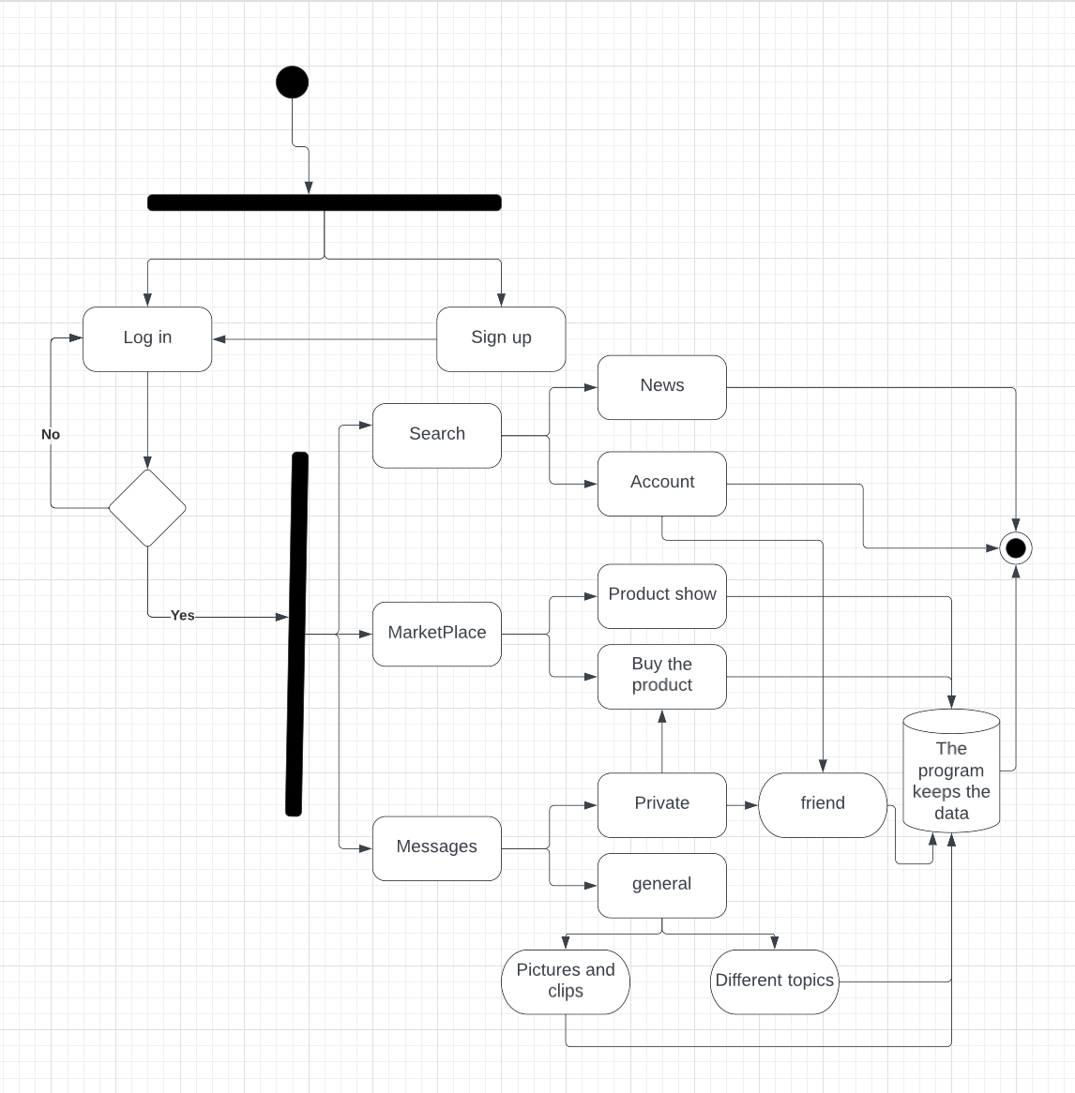

6|Page

1. **Project Use Case Mod:**

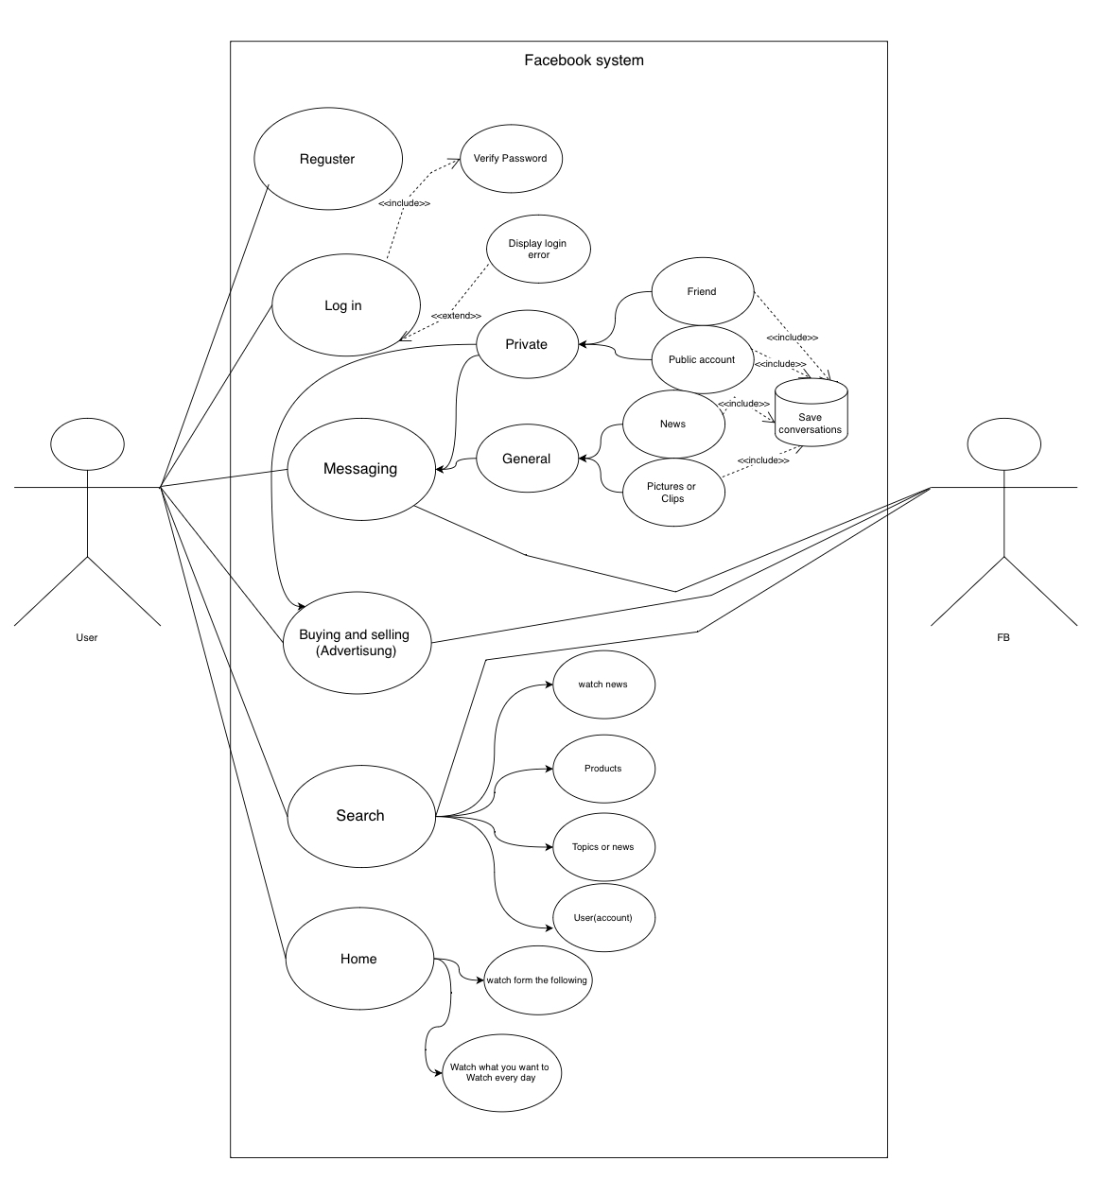

7|Page

|  |  |
| --- | --- |
| Use Case Name | Login |
| Actor | User |
| Difficulty | Easy |
| Pre-condition | The user is in login page |
| Post-condition | The user is in Homepage |
| Processes | The user enters his username and password , if the login is succeed then redirect to Home page , otherwise show error message |

|  |  |
| --- | --- |
| Use Case Name | Register |
| Actor | User |
| Overview | User register new account into the system |
| Pre-condition | System is up,app installed on his phone |
| Post-condition | 1-open app  2-click register  3-enter his name and email and address,phone nuber  4- click register  5-display message you are register |
| Processes | Display login page |

8|Page

1. **Creating Sequence Diagrams:**

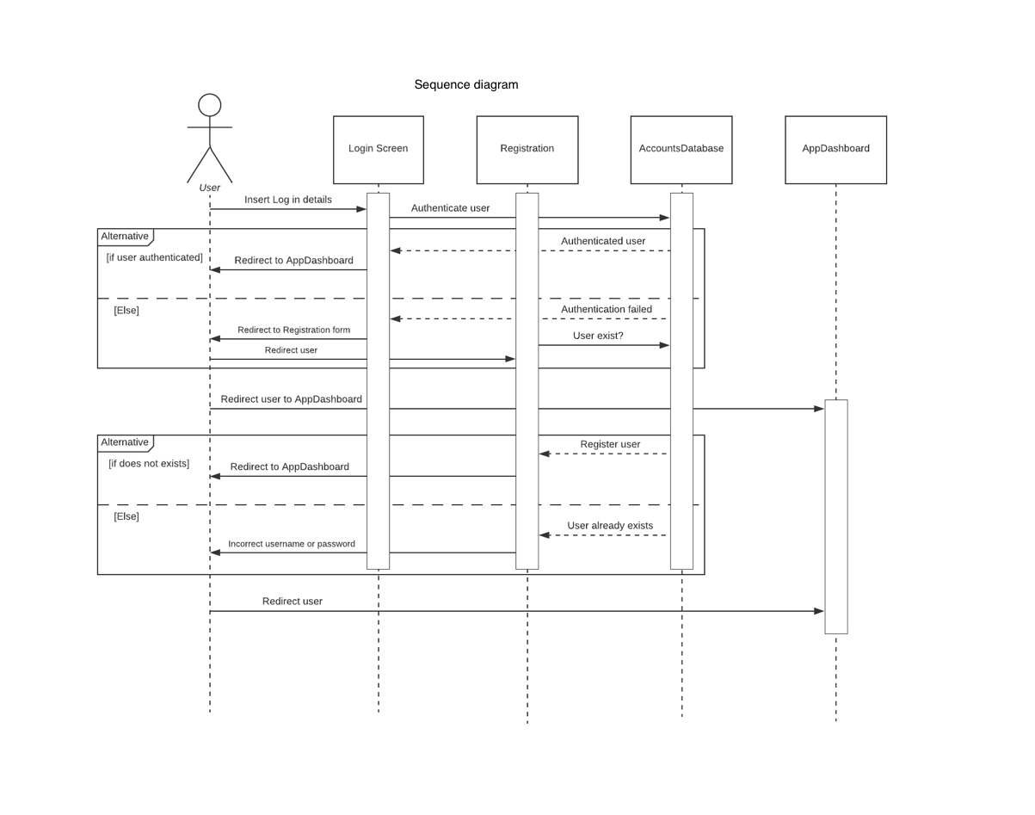

9|Page

1. **Creating a Class Diagram:**

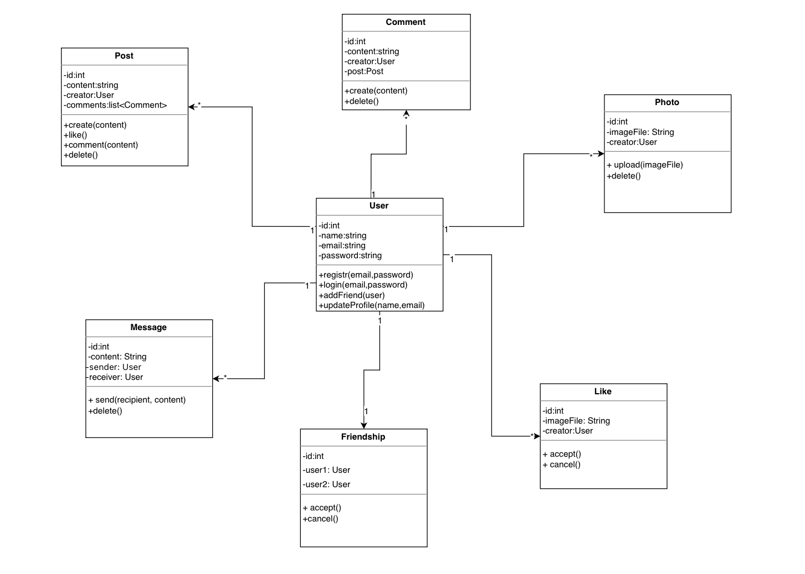

|10Page